A THREE-PHASE MODULAR MULTILEVEL DC–DC CONVERTER FOR POWER ELECTRONIC TRANSFORMER APPLICATIONS
ABSTRACT
A three-phase modular multilevel dc–dc converter is proposed and analyzed for power electronic transformer (PET) applications. Similar to a dual active bridge converter, the proposed converter comprises two three-phase inverters/rectifiers, coupled via a medium frequency (MF) transformer. The modular multilevel converter structure is used in the medium-voltage side to meet the high-voltage requirements and to reduce the dv/dt stress on the MF transformer. The frequency of the voltage through MF transformer (isolation frequency) is the same as the switching frequency of the power semiconductor devices, and zero-voltage switching-ON can be achieved for all the devices. With only one three-phase MF transformer, the proposed topology can greatly simplify the transformer design compared with the existed input-series output-parallel dc–dc converter structures for PET applications. A dual-phase-shift method is presented to control the output power and to balance the submodule capacitor voltages. Simulations and experimental results are provided to validate the theoretical analysis.

BLOCK DIAGRAM FOR PROPOSED SYSTEM
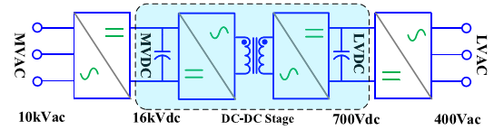
Fig. 1. Three-stage PET.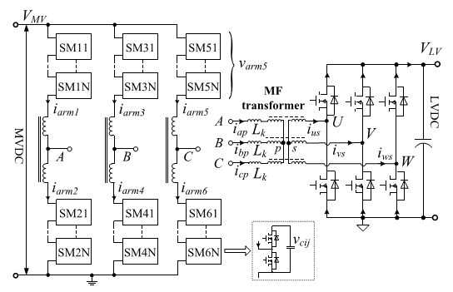
Fig. 2. Schematic of the proposed three-phase modular multilevel dc/dc converter.
DESIGNG SOFTWARE AND TOOLS:
MAT LAB /SIMULATION Software and simu power systems tools are used. Mainly control system tools, power electronics and electrical elements tools are used.

